Implemented on xx-xx-2017
Published on xx-xx-2017
UnionPay International QR Code Payment (JSON Interface) Implementation Guide for Acquirers
Version: 1.2
Version Changes

Version | Date | Revised by | Description
V 0.1 | January 29th, 2018 | Zuyi Zheng | UnionPay International QR Code Payment API Interface Implementation Guide (Merchant Presented Mode) for Acquirers
V 0.2 | March 13th, 2018 | Zuyi Zheng | Updated typos and Settlement Files
V 0.3 | March 13th,  2018 | Zuyi Zheng | Included Consumer-Presented Mode
V 0.4 | March 16th,  2018 | Zuyi Zheng | Updated transaction flow following feedbacks from Data Center
V 0.5 | March 18th,  2018 | Zuyi Zheng | Updated requirements of Settlement Files
V 0.6 | March 20th,  2018 | Zuyi Zheng | Optimized transaction flow following feedbacks from Data Center
V 0.7 | May 10th,  2018 | Zuyi Zheng | Optimized transaction flow following feedbacks from Data Center
V 0.8 | June 1st,  2018 | Zuyi Zheng | Update requirement of network protocol
V 0.9 | August 15th,  2018 | Yang Jiaqi | Add UPI Developer Platform introduction
V 1.0 | October 25th,  2018 | Zuyi Zheng | Confirmed Forwarding IIN (Merchant-Presented Mode)
V 1.1 | December 12th,  2018 | Zuyi Zheng | Required MCC to be consistent with what Acquirer assigned in the online message of Merchant-presented QR Code payment
V 1.2 | Jan.31st, 2019 | Zuyi Zheng | Modified system processing to Payload of Merchant-Presented QR Code considering circumstances that payload is over 512 bytes.
V1.3 | Sept.3rd, 2019 | Zuyi Zheng | Recommended best practice of transaction result inquiry of abnormal QR Code transactions
V1.4 | Nov. 13th, 2019 | Zuyi Zheng | Added refund requirement of UPlan and Instant Discount
Contents

1 Scope 1
2 References 1
3 Terms and Definitions 1
4 Roles 1
5 Network Access 2
6 Key Points of Transaction Workflow and Operation Rules 2
6.1 Transaction Workflow 2
6.1.1 Purchase ( Merchant-Presented ) 3
6.1.2 Purchase ( Consumer-Presented ) 5
6.1.3 Cancellation 6
6.1.4 Refund 7
6.1.5 Message Result Inquiry 7
6.1.6 Merchant Transaction Result Notification 8
6.1.7 Merchant Transaction Inquiry 8
6.2 Acquiring Operation Rules Key Points 9
7 Online Processing of the Acquiring System 9
7.1 Purchase 10
7.1.1 Interface between UAIS and Acquiring System 10
7.2 Cancellation 10
7.3 Refund 10
8 Settlement 11
8.1 Settlement Transaction Type 11
8.2 Settlement Files and Reports 11
9 Merchant Modification Requirements 11
9.1 Acquiring Merchant Management Platform 11
9.2 Merchant System 12
Annex 1 UPI Developer Platform Introduction 13
1.1 UPI Developer Platform Introduction 13
1.2 UPI QR Code Acceptance API 13
1.3 QR Code Merchant Gateway Service 14

UnionPay International QR Code Payment (JSON Interface) Implementation Guide for Acquirers

Scope

This document describes the required system changes for an Acquirer to implement UnionPay International QR Code products for both Merchant-Presented and Consumer-Presentedn Mode through JSON Format Interface, including requirements for network access, online transaction processing, transaction clearing and settlement, and merchant modification requirements.

References

UPI Acquiring Interface Service Technical Specification
UPI QR Code Encoding Specification_Merchant Presented QRC
UPI QR Code Encoding Specification_Consuemr Presented QRC
Guide to UionPay International Push Purchase and Push Cash Withdrawal

Terms and Definitions

GSCS: Global Switching and Clearing System
UMPS: UnionPay Mobile Payment System
UPLAN: UnionPay UPLAN marketing platform
UAIS: UPI Acquiring Interface System

Roles

UnionPay International QR Code payment system contains following roles: Merchant, Acquirer, Issuer, App provider and UnionPay.
UAIS: The UPI Acquiring Interface Service (UAIS) establishes a common, robust technology interface which allows the Acquirer to perform payment by using messages with JSON format. Merchant: Merchant is a business entity that engages in sales of providing goods or services to consumers, both online and offline.
Acquirer: Acquirer is an institution that conducts transaction acquiring business through the UnionPay Network or by a UPI-consented network.
Issuer: Issuer is an institution that conducts issuing business through the UnionPay Network or by a UPI-consented network.
APP Provider: APP provider is an entity providing the Consumer APP for cardholders to make QR Code payments. Its backend server is connected with UnionPay Mobile Payment System. The APP Provider may be a financial institution (e.g. Issuer App) or a non-financial institution.

Network Access

The institution will need to implement system changes detailed in the documents, and can only commence with their QR Code payment business after passing the network access verification test.
The protocal shall be TSL 1.2, due to the termination of TSL 1.0 and TSL 1.1.

Key Points of Transaction Workflow and Operation Rules

Under Merchant-Presented Mode, cardholders need to bind their UnionPay card into a mobile application (hereafter abbreviated as "APP") before conducting any UPI QR Code transaction, and then set an transaction verification method (e.g. APP PIN, fingerprint, etc). During payment, the merchant shall request a QR Code from Acquirer and displays the QR Code to the cardholder. The cardholder uses the APP to scan the QR Code of merchant. The transaction is initiated by the APP to complete the payment from the cardholder to the merchant. Each transaction using the Merchant Presented Mode will require user verification.
The merchant QR code can be either a static or a dynamic code. The static code is for long-term use and typically does not include a transaction amount (except for a good or service that has a fixed price). The dynamic code is generated for each transaction and will include a transaction amount. After the transaction is successfully processed, the dynamic code shall become invalid and should no longer be displayed to a cardholder. The dynamic code can be displayed by the merchant system client, which includes but is not limited to the POS, a merchant APP, an e-commerce system, a TV commerce system, a multimedia terminal and vending machines.

Under Consumer-Presented Mode, cardholder QR Code is obtained and displayed on the APP, and then the merchant scans with a QR Code scanner to initiate the purchase transaction. During the payment, the cardholder displays a payment QR Code on the APP for merchant to scan. The payment card is the default card set by the cardholder (the cardholder can choose to replace the bound bank card in the APP).
When the APP initiates a payment QRC application, UnionPay generates a payment code and sets a valid time for it; the payment code can be used once in the valid time and cannot be used if the valid time exceeded.

Transaction Workflow
For UPI QR Code transaction through JSON Inteface, the Acquirer will need to support these transaction types: purchase, cancellation, refund and message result inquiry.
The Acquirer will also need to support the generation of a merchant QR code, scanning QR Code, a transaction result notification to the merchant, a message result inquiry, as well as a transaction result notification from UPI Acquiring Interface System (UAIS)
If the Acquirer supports the UnionPay UPLAN marketing platform, then they will also need to support any UPLAN-related updates as well.

Purchase ( Merchant-Presented )
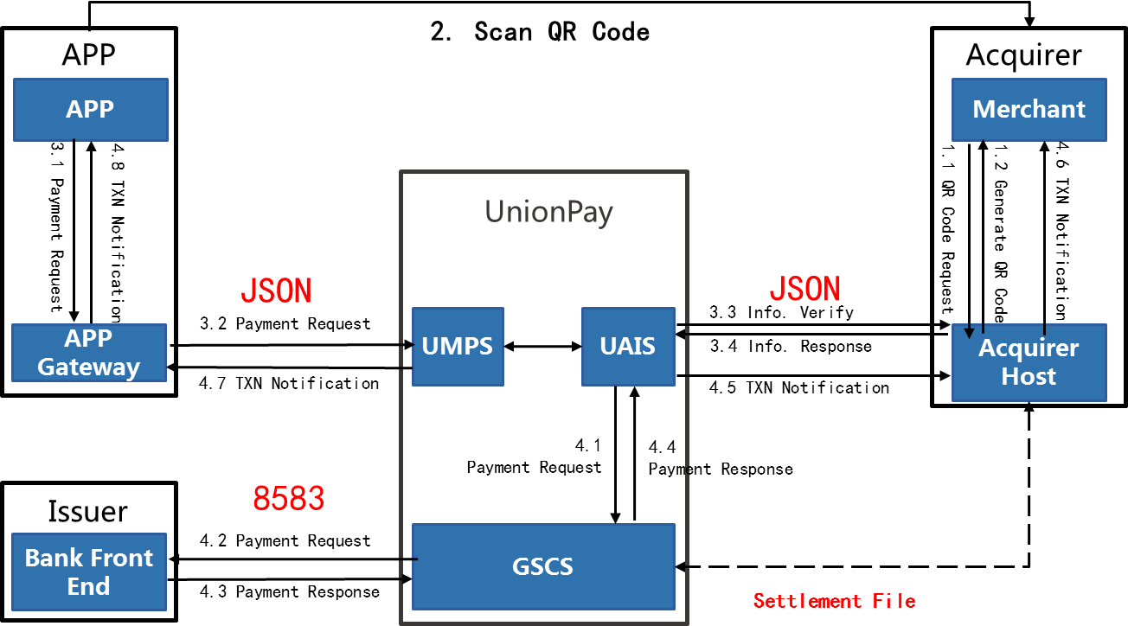

- Merchant requests an EMV QR Code from the Acquirer. (Forwarding IIN should be IIN of UAIS, which is 00520446.)
- The Acquirer generates the EMV QR Code and returns to the merchant.
Note: the QR code requested by merchants can be either a long-term static QR code or a one-time dynamic QR code.
- Cardholder scans the QR Code showed by the merchant via their APP, which then parses the QR Code to obtain the relevant information of merchant (including elements such as the merchant ID, merchant name, merchant type, merchant location, transaction amount, transaction currency and country code) and initiates a payment request to the UMPS system.
Note: For a static QR Code payment, if the transaction amount is not included in the QR Code then the cardholder will need to type the payment amount into the APP and confirm to pay. For a dynamic QR Code payment, the card holder will not need to type the payment amount into the APP but they will need to confirm the payment (need to type in their CDCVM or PIN into the APP).
- UMPS tranfers the payment request (including merchant information, card information, QRC voucher number, etc.) to UAIS, and UAIS initates the merchant verification request to Accquirer. The length limit is 512 bytes of transmitting the payload information from UAIS. If original QR Code payload exceeds 512 bytes, only UnionPay-related information will be included in the payload and be sent to Acquirer.
- The Acquirer checks the validity of merchant information. If merchant info. is NOT valid, the Acquiring system will return a payment response to UAIS and rejects the transaction. UIAS then sends a rejected payment result response to the APP Gateway, and the APP Gateway sends the rejection result notification to the APP.
- The Acquirer checks the validity of the merchant information. If merchant info. IS valid, Acquirer returns a payment reponse to UAIS and confirm the transaction. In this response, Acqurier should ensure MCC included in the message is consistent with the MCC when Acquirer assigned corresponding UnionPay QR Code merchant.
- UAIS composes the payment request message according to the transaction information confrimed by Acuiqring system and sends the payment request to GSCS.
- GSCS transfers the payment request (including QRC voucher number) and sends to the Issuer for authorization and obtain the corresponding payment response.
- If the transaction is successful, GSCS returns a payment response to UAIS. UAIS returns a transaction result notification to Acquirer, and then the Acquirer sends the transaction result notification to the merchant.
- UAIS also returns a transaction notification to UMPS.
- UMPS sends the transaction result notificaiton to the APP Gateway, including the QRC voucher number. The APP Gateway sends the payment result response to the cardholder APP, including the QRC voucher number.
Notice:
- If the UAIS does not receive the response of information verification from Acquirer within 10s, it will reject the merchant-presented QRC purchase request from the APP Gateway and send the transaction notification to the Acquirer with the rejected status.
- If the UAIS does not receive the transaction notification response from the Acquirer within 10s, it will store and forward transaction notification request message.

Purchase ( Consumer-Presented )
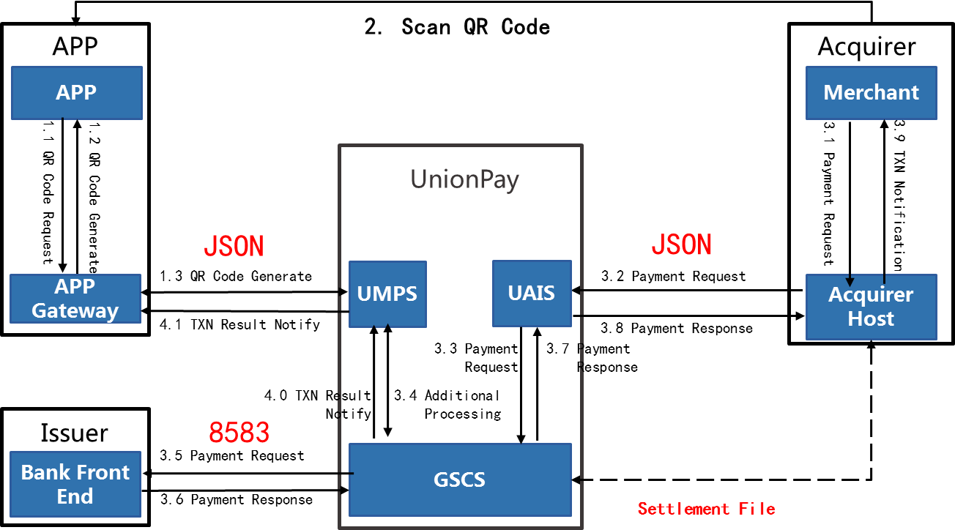

- Cardholder requests an EMV QR Code from UMPS and display the QR Code with APP.
- After scanning the QR Code, the merchant submits a payment request to Acquirer, and Acquirer initiates the payment request to UAIS.
- UnionPay system will verify the transaction information including the QR Code; if the verification is approved, UnionPay system may, depending on the QR Code transaction requirement set by APP, choose to trigger an additional processing request to cardholder, then APP verifies the identity of cardholder and cardholder confirms to submit payment.
- If additional processing fails, UnionPay system will directly respond to Acquirer; if the previous step successds, UnionPay system will continue initiating an authorization request to the issuer;.
- After receiving the success response, UnionPay system returns a purchase response to the Acquirer (may choose to return the QRC payment voucher number (F125) according to the situation of the acquirer);
- Meanwhile, UnionPay system sends a transaction notiofication to cardholder.
- The transaction is successfully completed and the merchant prints the transaction receipt according to the cardholder's request, signature will not be required.
Notice:
- When Acquirer does not receive the PURCHASE response message within 45 seconds, it can initiate a message result inquiry, using the Message ID of the PUECHASE massage to check if the payment is successful.
- UAIS system will return the PURCHASE transaction outcome (approved/rejected/pending) and settlement information to the Acquirer.

Cancellation
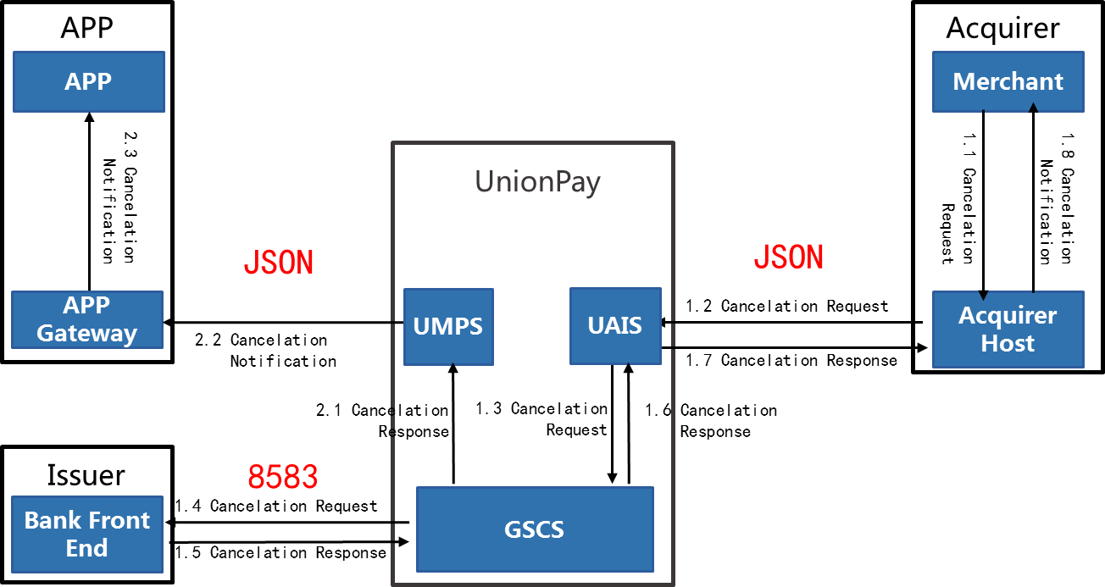

- Merchant initiates a CANCELATION request to Acquirer through using the QRC voucher number.
- Under Merchant-Presented Mode, the Acquirer matches the transaction according to QRC voucher number and initiates an cancelation request to UAIS;
Under Consumer-Presented Mode, the Acquirer uses the Message ID of PURCHASE to void the consumer-presented QRC purchase.
- UAIS transfers the cancelation requets to GCGS, and then GSCS sends the canelation request to the Issuer.
- The Issuer sends the cancelation response to GSCS, and GSCS returns the cancelation response to UAIS and UMPS.
- UAIS sends the cancelation response to the Acquirer, and the Acquiring system returns the cancelation notification to the merchant.
- UMPS sends the CANCELATION notification to the APP through APP Gateway.

Refund
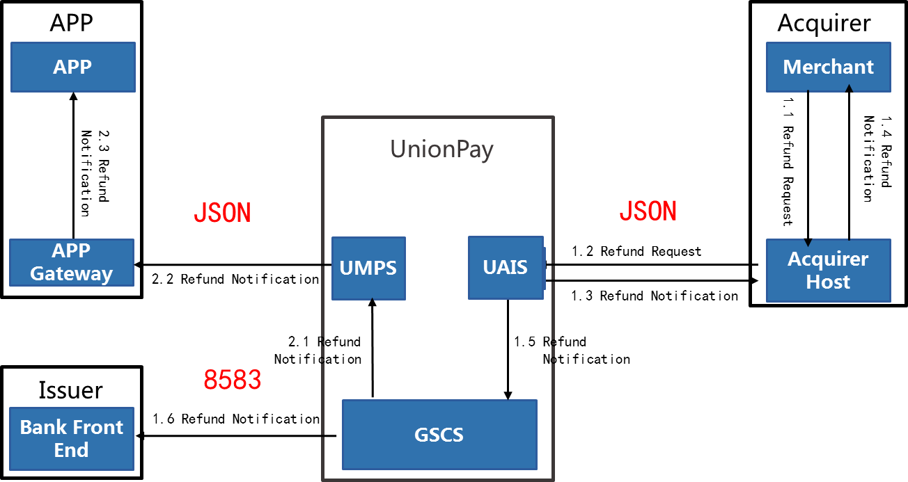

- Merchant initiates a REFUND notification to the Acquirer using the QRC voucher number.
- The Acquirer matches the transaction with the QRC voucher number and submits a refund request to UAIS.
- UAIS immediately responds to the Acquirer with a refund response, and the Acquirer sends the refund notification to merchants.
- UAIS forwards the refund notification to GSGC, and GSCS sends a refund notification to the Issuer.
- GSCS forwards the refund notification to UMPS, and UMPS sends a refund notificaiton to the APP Gateway, and the APP gateway sends a refund notification to the APP.

Message Result Inquiry

If the Acquirer does not receive the transaction notification from the UAIS system within 45s, including purchase, cancelation and refund, Acquirer can initiate a message result inquiry request to the UAIS, using Message ID to check the transaction status. UAIS returns a message result inquiry response to the Acquirer to indicate whether the payment transaction is approved, rejected or pending.

Merchant Transaction Result Notification
For a purchase transaction (not initiated by the merchant), the Acquirer sends a transaction notification to the merchant only after receiving a transaction success response from UAIS.
For cancellation and refund transactions (initiated by the merchant), Acquirer returns the transaction result to merchant.
Transaction result notifications must contain the QRC voucher number.
If a UPLAN coupon is used in a transaction, then it is advisable to inform the merchant of the offer information-related content in the transaction result notification.
If a merchant code stores the data in the Additional Data Field Template (ID62) that the merchant requests from the card holder / APP (suh as card holder membership number, shipping address etc.), it is advisable to inform the merchant of the data in the transaction result notification.

Merchant Transaction Inquiry
If a purchase transaction appears to have been completed, but the merchant fails to receive the transaction result notification then the merchant shall be able to initiate a transaction inquiry request to the Acquirer to check whether the transaction has been completed or not.
Best Practice Recommendation:
For Merchan-Presented QR Code merchants with capable infrastructure (Merchant APP, POS Terminal, MIS etc.), merchant shall submit Transaction Result Inquiry to Acquirer system every 10s (polling); and for Consumer-Presented QR Code merchants, after transaction is iniated in 10s, merchant shall submit Transaction Result Inquiry to Acquirer system every 4s.
Acquirer system will deal with submitted Transaction Result Inquity according to message back from UAIS: if Acquirer received transaction notification or payment response from UAIS, Acquirer shall forward transaction result notification to merchant; if Acquirer has not received any transaction notificaiton or payment response from UAIS, Acquirer shall submit Transaction Result Inquiry to UAIS to check the status of transaction.
If cardholder APP receives transaction notification but merchant or terminal has no transaction notification received, thoeratically the transaction is succeeded. Merchant shall wait for response of transaction result inquiry.
For a dynamic code, if the transaction result notification is not received within the validity period of the QR Code then the QR Code shall be removed from display and a transaction query is sent to the Acquirer system. The merchant can initiate a transaction inquiry to the Acquirer manually. The inquiry can be initiated for using Message ID. Please note that Acquirers will need to allow a merchant to query a transaction for multiple times.
For a static QR code, the merchant can initiate a transaction inquiry to the Acquirer manually, and the merchant can inquire about a single transaction via the Message ID.
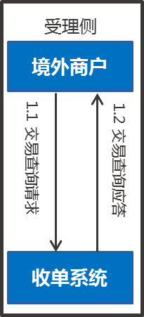
Acquirer
1.1 Transaction query request
1.2 Transaction query response
Merchant
Acquiring System

Acquiring Operation Rules Key Points
Key poitns of rules related to Acquirer are as followed:
- Receipt printing is optionally supported
The merchant does not need to print a receipt for a QRC payment in the Merchant Presented Mode. The valid vouchers of QR code payment include electronic transaction data recorded in Acquirer transaction system or a replacement receipt generated according to the electronic transaction data (the replacedment receipt must be stamped with the Acquirer’s seal), or a good/service delivery voucher.
- The Acquirer should support the merchant to use QR Code voucher numberto initiate a purchase cancellation or refund transaction, and a merchant should not reject the refund request of cardholder due to the lack of a transaction voucher.
- In QR Code payments there is one restriction for a chargeback to Acquirer by the Issuer when compared to existing dispute management. For a QR Code payment, the following chargeback reason code is not applicable:
4527 -- the Acquirer's reply exceeded the time limit or the reply code is 04.
Aside from this special provision, the dispute rules for QR Code payments are the same as that of the corresponding cards in the UnionPay International Business Operations Regulations.

Online Processing of the Acquiring System

This section describes the requirements for online messages between the Acquiring system and the UnionPay system (UAIS). Please refer to the UPI Acquiring Interface Service Technical Specification for details of online message formats and message processing requirements of the Acquiring system. In case of any inconsistency between this document and above document, the latter shall prevail.
For message exchange between the Acquiring system and merchant, please refer to the relevant contents in Section 6.1 for transaction message requirement recommendations (merchant code generation, merchant transaction result notification, and merchant transaction inquiry).

Purchase

Interface between UAIS and Acquiring System
When a cardholder scans a merchant QR code to initiate a transaction from an APP, the payment request will be sent to the Acquirer via UnionPay system (UMPS/UAIS). The payment request and payment response between UAIS and acquiring system are NEW messages with JSON format, and the payment request contains merchant information, card information, and the QRC voucher number.
When the merchant information is received, the Acquirer needs to check the merchant information (such as the merchant name and MCC) for validity, and also whether the merchant is in a ‘normal’ status or not. If the merchant name, MCC or other information is incorrect or the merchant status is abnormal, it is recommended that the Acquirer rejects the transaction.
If the cardholder chooses UPLAN coupons when initiating the payment request, discounted amount will be filled in the field “Discount” when UAIS sending the transaction notification to Acquirer. The transaction amount and cost amount (cardholder acutaly pays) will appear in Field “Transaction Information” in transacation result notification. The Acquirer can inform the merchant of the offer related information in the transaction result notification.

Cancellation
A cancellation transaction must be initiated on the same day of the original transaction for the full amount of the transaction.
The Acquirer must support the merchant using QRC voucher number (stored in either the merchant transaction notification or the card holder’s cellphone APP notification) to initiate a cancellation transaction.
When the Acquirer does not receive the cancelation response within 45 seconds, it can initiate a message result inquiry to UAIS, using the Message ID of the cancelation to check the result of the cancelation request message.

Refund
A refund transaction can be initiated within 30 days (including the current day) for multiple refunds, as long as the accumulated refund amount does not exceed the original transaction acmount.
If the Acquirer does not receive the REFUND response within 45 seconds, it can initiate a message result inquiry to UAIS, using the Message ID of the refund to check the message status.
For QR Code UPlan transaction, acquirer should initiate refund with discounted amount; for Instant Discount transaction, acquirer should initiate refund with original amount before discount.

Settlement

Settlement Transaction Type
With JSON Format Interface connecting to UnionPay, all the online transactions are handled by UAIS after Acquirers verified and approved the transaction information, thereby settlement are in Single Message Mode for all Acquirers.

Settlement Files and Reports
To facilitate the settlement with merchants, UnionPay provides the following files and reports to the Acquirer.

QRC payment transactions using Merchant Presented Mode will be reported as an e-commerce item in the Institution Net Settlement Summary C602DZ.

Please refer to Technical Specifications on Bankcard Interoperability, Part III File Interface to find more details about the file exchange relationship between UPI and UPI Members in the inter-bank transaction network, including stipulations on the file access mode, file name, and record format.

SN | File Classification | Direction | File Name
Files
1 | Audit Trailer | IN | IFDYYMMDD01ACOMN
2 | Dispute File | IN | IFDYYMMDD01AERRN
6 | Funds collection File | IN | IFDYYMMDD01FCP
7 | Rate File | IN | IFOYYMMDD01RAT
8 | BIN File | IN | IFOYYMMDD01BIN
9 | Interchange/Service Fee File | IN | IFDYYMMDD01AFEEDTL
Reports
1 | Summary Report | IN | IFRYYMMDD01C602DZ-TTT-SSS
2 | Dispute Report | IN | IFRYYMMDD01C605DZ

Merchant Modification Requirements

Acquiring Merchant Management Platform
It is recommended that the Acquirer develops or updates a merchant management platform to support merchants with QR code transactions. The merchant management platform should support functions including (but not limited to):
- Merchant profile setup and maintenance
- Merchant QR Code generation (static / dynamic code)
- Carholder QR Code recognization
- Send merchant transaction result notification
- Support access and interactions from Merchant system

Merchant System
It is recommended that the merchant management system be developed or updated to support QR Code transactions. A merchant system may include (but not limited to) a POS, a Merchant APP, an e-commerce system, a TV commerce system, a multimedia terminal, and a self-service vending machine etc.
To support QR code transactions, the merchant system should support functions including but not limited to:
- Merchant registration
- Merchant QR Code application (static / dynamic) and display
- Receiving a merchant transaction result notification
- Merchant initiated cancellation and refund transactions using the QRC voucher number
- Merchant transaction inquiry
  - Initiate an automatic or maual query with Message ID.
- Transaction statistics

Annex 1 UPI Developer Platform Introduction
UnionPay International Developer Website: https://developer.unionpayintl.com

UPI Developer Platform Introduction
UPI Developer Platform comprises such four components as Open API, Solution, Partner and Support. Based on these services, users can experience advanced technical products and comprehensive payment solutions of UPI by calling open API, and rapidly acquire secure and reliable payments capacity to their own products. Four sections on the Platform including Open API, Solution, Partner and Support provide users with respective resources and instructions. To explore the contents exhibited by the aforesaid four sections, users can register to create an account to update their personal information, initiate consultation or follow-up questions by filing order service, or refer to sandbox testing information already filed and sandbox testing statistical data already performed.
For further instructions, please refer to this website:
https://developer.unionpayintl.com/cjweb/support/file/online/0/1

UPI QR Code Acceptance API
UPI QR Code product can be used by UPI QR Code merchants to support a low-cost, convenient and secure innovative payment solution by either displaying a static/dynamic QR Code (Merchant-Presented) or scanning consumer's payment QR Code (Consumer-Presented). This set of API provides all the necessary functions, allowing acquirers to connect to UPI system with JSON message instead of traditional ISO 8385 message, and supporting UPI QR Code payments in both Merchant-Presented and Consumer-Presented mode.
The key features include:
- Open. The platform is open. QR Code can be displayed on merchant's app. The transaction can be completed with any APP that can support UPI's QR Code.
- Secured. Security is a basic requirement for payments. UPI adopts Tokenization technology which supports risk control for whole transaction process, making sure of safety and preventing leakage of account information.
- Interoperability. UPI's QR Code is of EMVCo standard and extendable for future use of compatibility of other international card schemes, which makes QR Code payment in and out of mainland China interoperable.
- Integrity. UPI's QR Code payment sticks to 4-party mode which is almost the same with bank card transaction only except for the information interaction. UPI's QR Code payment has a whole integrated mechanism of business, risk control, techniques which secures user's capital.
For any further information, please refer to this website:
https://developer.unionpayintl.com/cjweb/api/detail?apiSvcId=16

QR Code Merchant Gateway Service
QR Code Merchant Gateway Service Platform is a Turn Key QR Code payment solution for acquirers and merchants.
Application scenarios typically include:
- Small Amount Payment: High frequency small amount payment scenarios where merchants are sensitive to terminal cost, e.g. night fair, street vendors, etc.
- Inclusive Finance: Suburban areas where payment infrastructures are less developed, e.g. agricultural products sales, etc.
- Cash on Delivery: Cash on delivery through mobile payment, e.g. order takeout, housekeeping, home delivery service, etc.
- Other E-Payment: Taxi, vending machine and other emerging e-payment application scenarios.
For any further information, please refer to this website:
https://developer.unionpayintl.com/cjweb/solution/detail?solId=2

QRC voucher number refers to a string of numbers as the transaction voucher number that is generated by UnionPay system. It can be obtained by the cardholder in the APP transaction notification, and included in the transaction notification to merchant as well. The QRC voucher number is unique and is used for subsequent transaction processing.

